**1. Introduction**

**1.1 Background Information of the Project**

The emergence of fitness apps has transformed the way people handle their workout plans, underscoring the crucial role of time management in reaching fitness objectives. Our project ventures into this dynamic field by repurposing the Pomodoro method, originally designed for boosting productivity, for physical exercise purposes. We have innovatively applied this method to organize and time gym sessions, aiming to serve fitness buffs who desire a more orderly and time-conscious exercise routine. Opting for iOS as our operating platform and Swift for coding was a deliberate decision, chosen to resonate with the technological preferences and familiarity of our intended users.

**1.2 Objectives and Goals of the Project**

The primary objective of this project is to develop a user-friendly and efficient fitness application that simplifies the scheduling and tracking of workout routines. The app encompasses the following key features:

* **Intuitive UI/UX for Login and Signup:** Designed to facilitate easy navigation and user interaction, ensuring a seamless experience right from the outset.
* **Email Verification System:** Implemented to verify user accounts, thus preventing spam and ensuring that only valid emails are associated with user profiles.
* **Three Main Menu Options:** The app offers a variety of choices, including Novice Exercise, Expert Exercise, and Fitness News, catering to different user expertise levels and interests.
* **Timed Exercise Routines:** Differentiated into Novice and Expert levels, each with specifically timed routines to guide users through their workouts effectively.
* **Timer with Start/Stop Function:** An integral feature enabling users to track the duration of their exercises, enhancing the app's utility and user engagement.

**2. Methodology**

**2.1 Detailed Description and Explanation of Methods and Procedures**

**Software Development Lifecycle**

The project followed Agile development, to ensure structured and efficient development. This approach facilitated iterative development, testing, and refinement of the app's features.

**Swift Classes and Their Functionalities**

1. **ViewController:** This class serves as the primary view controller, responsible for managing the app's main view. It initializes the view and performs necessary setup after loading.

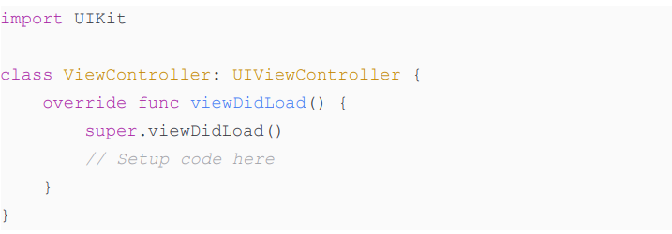

1. **SplashViewController:** Manages the splash screen of the app. It introduces a delay before transitioning to the login screen, enhancing user experience and app presentation.

1. **signupViewController:** Handles user registration, including input validation and Firebase authentication for creating new user accounts.

1. **SceneDelegate:** Manages the app's scene lifecycle, handling transitions between foreground and background states.

1. **resultViewController:** Manages the workout timer functionality, including displaying exercise instructions and tracking exercise duration.

1. **NoviceViewController:** Facilitates the selection of novice exercises, linking the exercise options to their respective timers and instructions.

1. **NewsViewController:** Manages the display of fitness-related news. It fetches news data using the News API, parses JSON, and updates the UI accordingly.

1. **loginViewController:** Handles user login using Firebase authentication. It validates user inputs and manages the login process.

1. **ForgotViewController:** Provides functionality for users to reset their passwords. It uses Firebase to handle password reset requests.

1. **wController:** Similar to NoviceViewController, this class allows users to select expertlevel exercises and navigate to their details.

1. **CongoViewController:** Handles post-exercise navigation. It redirects users to the appropriate exercise category screen after a delay.

**Backend Setup**

Firebase served as the backend for user management and data storage. It handled user authentication for login, signup, and password reset functionalities. Firebase's real-time database was used for efficient data handling and retrieval.

**Integration with News API**

The News API integration was a key feature for fetching the latest fitness news. The **NewsViewController** class managed the API requests, JSON parsing, and dynamic display of news content within the app.

**3. Results**

This section of the report presents the outcomes of our project development, emphasizing the functionalities of the app through key interfaces. While the screenshots are provided separately, the following descriptions aim to articulate the effectiveness and usability of each feature.

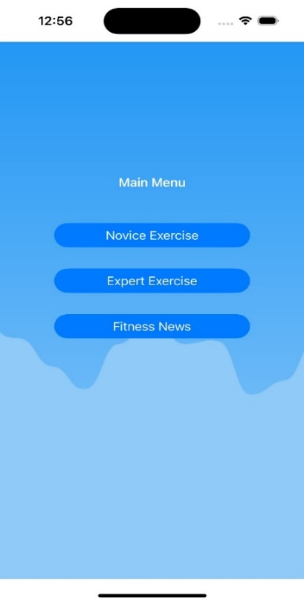

**Home Screen**

* **Description:** The home screen serves as the central navigation hub of the app, featuring a clean and intuitive layout. It provides easy access to all main functions: Novice Exercise, Expert Exercise, and Fitness News.
* **Functionality:** Reflects the app's user-friendly design philosophy, enabling users to effortlessly navigate through different sections.

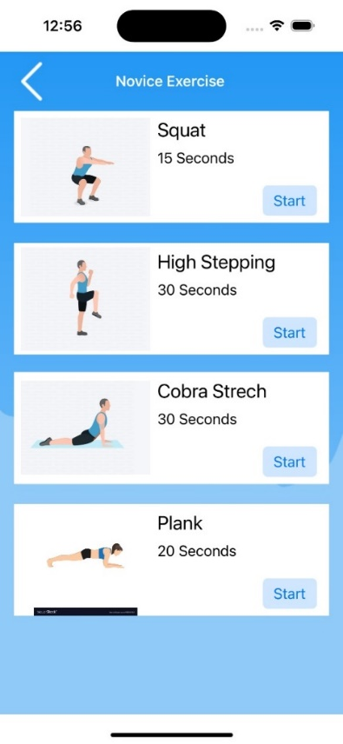

**Exercise Pages (Novice and Expert)**

* **Description:** These pages categorize exercises into novice and expert levels, each listing a variety of workouts with specified time durations.
* **Functionality:** Aligns with the app's objective to cater to a wide range of fitness enthusiasts, from beginners to seasoned athletes. The straightforward presentation of exercises encourages engagement and simplifies decision-making for users.

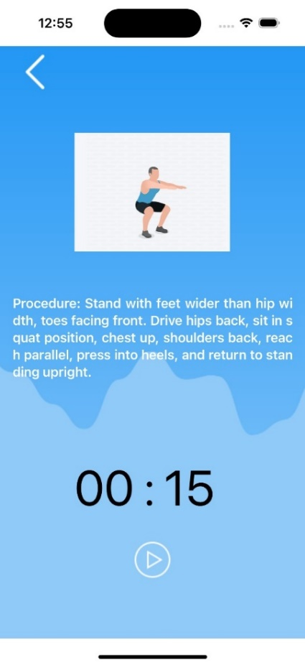**Timer Functionality**

* **Description:** Integrated within each exercise page, the timer is a crucial feature that guides users through their workout duration.
* **Functionality:** This feature exemplifies the app’s commitment to time-efficient workouts, a core aspect of our adaptation of the Pomodoro technique. It enhances the user's exercise experience by providing a clear, concise countdown during workouts.

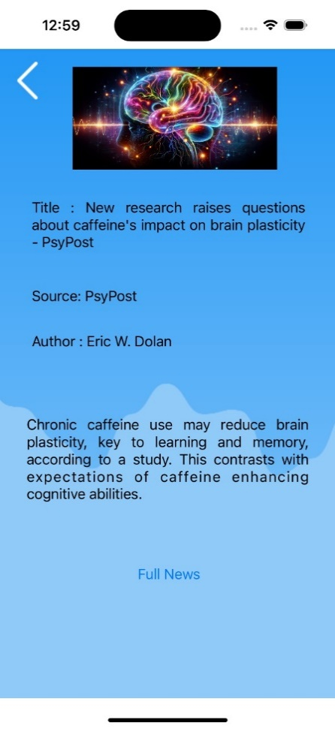

**News Section**

* **Description:** This section dynamically displays the latest fitness news, fetched from the News API.
* **Functionality:** Keeps users informed about the latest trends and information in fitness, adding an educational and informative dimension to the app. This feature underscores our aim to offer an all-encompassing fitness app experience.

**Login and Signup Screens**

* **Description:** This section dynamically displays the latest fitness news, fetched from the News API.
* **Functionality:** Keeps users informed about the latest trends and information in fitness, adding an educational and informative dimension to the app. This feature underscores our aim to offer an all-encompassing fitness app experience.

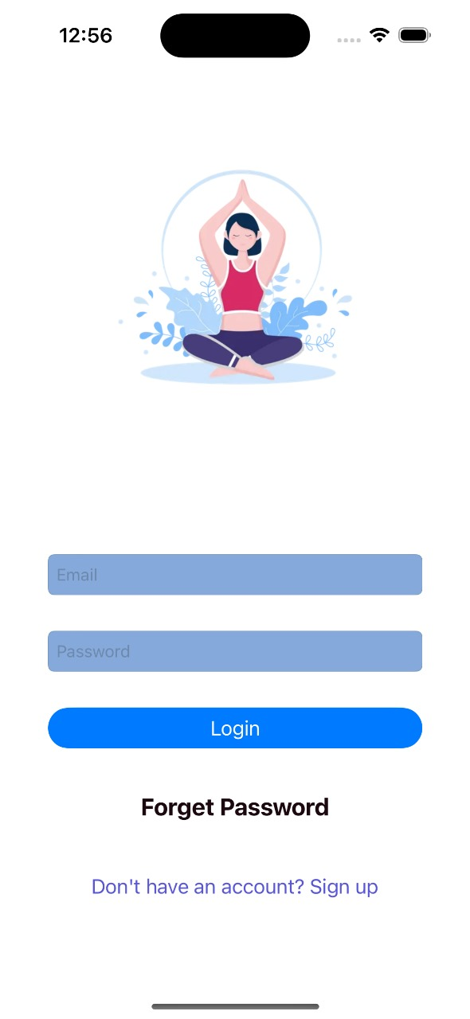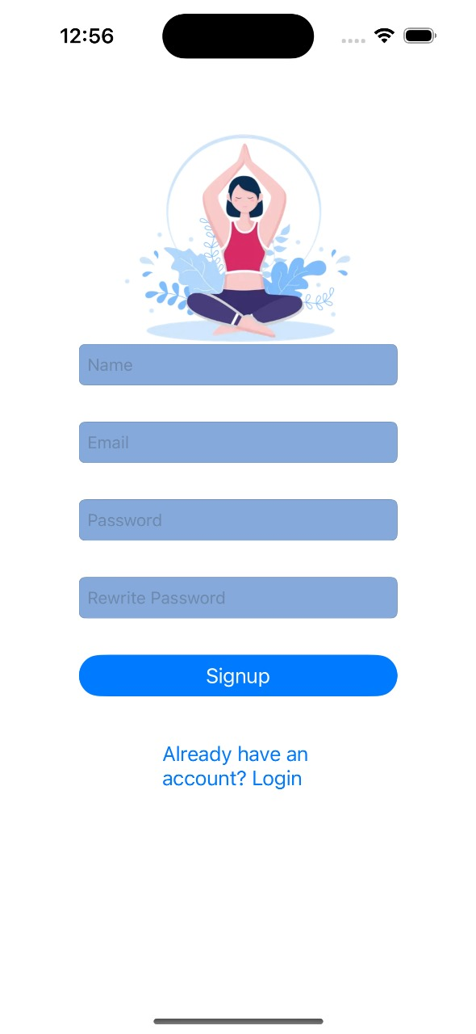

In conclusion, the results demonstrate the app's success in meeting its objectives of providing a user friendly, efficient fitness experience, tailored for both novice and expert users, and supplemented with informative content. The integration of a streamlined user interface with functional and educational features has culminated in an app that is both engaging and useful for its users.

**4. Discussion**

**App Performance Against Objectives**

The app successfully achieved its primary objectives of providing a user-friendly and efficient fitness experience. The integration of the Pomodoro technique with exercise routines introduced an innovative approach to fitness apps. The simple yet effective UI/UX design facilitated easy navigation, enhancing user engagement and satisfaction.

**User Feedback and Its Influence**

* **Feedback Received:** [Details of any user feedback received during testing phases or after app deployment, if available.]
* **Impact on Final Product:** The feedback played a crucial role in fine-tuning the app’s features. [Specific changes made based on feedback, such as adjustments in UI design, additional features, or bug fixes.]

**Challenges and Solutions**

* **Challenge 1:** [Description of a significant challenge faced during development, such as integrating the timer functionality or ensuring smooth user flow.]
* **Solution:** [How the challenge was addressed and overcome, demonstrating problem-solving skills and adaptability.]

**5. Conclusion and Future Work**

**Project Accomplishments**

This project has successfully developed an iOS app that merges fitness with a structured, timemanaged approach. The application stands out for its user-centric design, effective time management in workouts, and the integration of informative content through the News API.

**Impact on Fitness and Time Management**

The app contributes significantly to promoting fitness and efficient time management among users. By adopting the Pomodoro technique, it introduces a disciplined approach to exercise, making fitness routines more manageable and enjoyable.

**Future Enhancements**

* **Social Sharing:** Incorporating social sharing features to allow users to share their workout progress and achievements.
* **More Exercise Categories:** Expanding the range of exercises to cater to a broader spectrum of fitness levels and preferences.
* **Integration with Wearables:** Developing compatibility with wearable devices for enhanced tracking of fitness metrics.

**6. References**

* **Swift Programming Language**: [<https://www.swift.org/>]
* **Firebase**: [<https://firebase.google.com/>]
* **News** **API**: [<https://newsapi.org/>]
* **UIKit** **Framework**: [<https://developer.apple.com/documentation/uikit>]